🚀 Lab Report: Azure Virtual Network & Network Security Group (NSG) Implementation
By: Mayank Sharma

1. 🎯 Lab Objective
The objective of this lab is to architect a secure network environment in Azure by:
- Designing and implementing a segmented Virtual Network (VNet)
- Configuring Network Security Groups (NSGs) to filter traffic between subnets
- Leveraging Application Security Groups (ASGs) for scalable, role-based security rules

2. 🧠 Core Concepts

2.1 Virtual Network (VNet) & Subnets
A Virtual Network acts as a private network in Azure, providing isolation for resources. However, it does not enforce traffic control by default. Subnets allow logical segmentation of the network (such as Web and Application layers), improving organization and management.

2.2 Network Security Group (NSG)
An NSG functions as a stateful firewall applied at either the Subnet or Network Interface (NIC) level. It filters traffic using parameters like source, destination, port, and protocol, enabling precise control over inbound and outbound traffic.

2.3 Application Security Group (ASG)
Application Security Groups allow logical grouping of Virtual Machines based on their role. Instead of managing IP addresses, rules are defined using these logical groupings, making the system more scalable and easier to maintain.

3. ⚙️ Implementation Phases

🔹 Phase 1: Creating the Network Foundation
- VNet Provisioning: Created vnet-demo-lab with address space 10.0.0.0/16
- Subnet Segmentation:
  - web-subnet (10.0.1.0/24): Reserved for web-facing workloads
  - app-subnet (10.0.2.0/24): Reserved for internal application logic
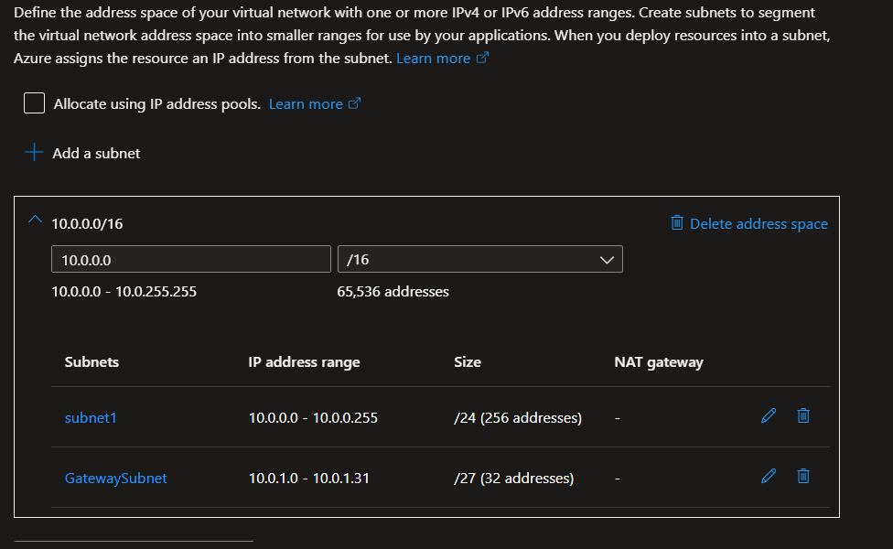

🔹 Phase 2: Deploying Virtual Machines & Web Services
- Workload Deployment:
  - Deployed vm-web in the web-subnet
  - Deployed vm-app in the app-subnet
- Web Server Setup: Configured a web server on vm-web and verified its availability
- Initial Access: Allowed HTTP traffic (Port 80) to confirm connectivity via the public IP
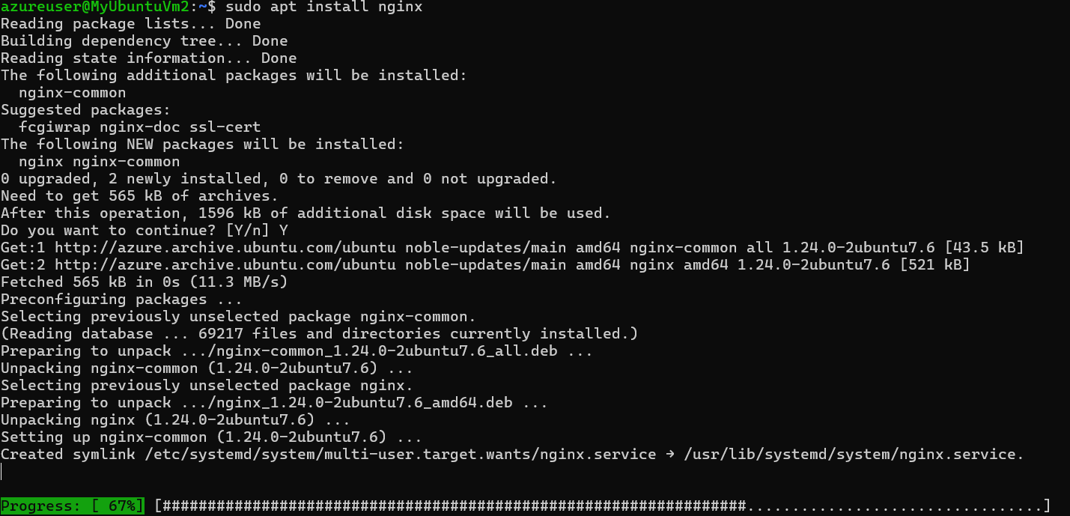

🔹 Phase 3: Configuring Security Rules (NSG)
- NSG Creation: Created nsg-web and associated it with the web-subnet
- Rule Precedence Test:
  - Configured an Allow rule for HTTP traffic
  - Configured a Deny rule with higher priority
  - Observed that traffic was blocked, demonstrating that lower priority numbers take precedence in Azure NSGs
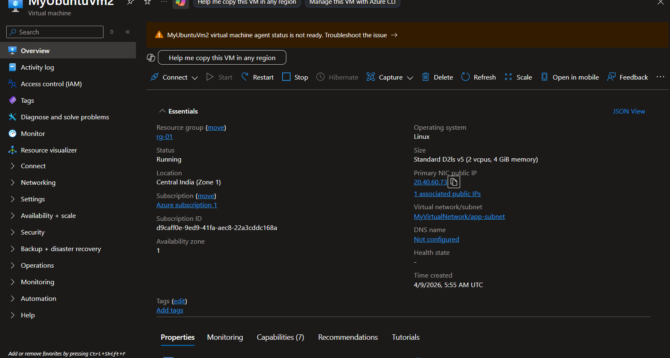

🔹 Phase 4: Advanced Security with ASGs
To simplify rule management, Application Security Groups were implemented:
- ASG Creation: Created asg-web and asg-app
- Association: Linked:
  - vm-web → asg-web
  - vm-app → asg-app
- Rule Configuration: Updated NSG rules to allow traffic:
  - From asg-app
  - To asg-web
  - Over HTTP (Port 80)
This enabled role-based access control instead of IP-based rules.

4. 🧪 Testing & Verification
Test Scenario | Action | Expected Result
Public Access | Access web VM via Public IP | Denied (Secure)
Internal Access | Access web VM from app VM using private IP | Success (Authorized)
Priority Test | Deny rule given higher priority than Allow | Traffic Blocked

5. 📊 Summary: NSG vs ASG
Feature | NSG (Network Security Group) | ASG (Application Security Group)
Primary Function | Firewall for filtering traffic | Logical grouping of VMs
Rule Definition | Based on IP addresses | Based on roles (tags/labels)
Placement | Applied to Subnet or NIC | Used inside NSG rules
Scalability | Harder with many IPs | Highly scalable and flexible

6. 🏁 Conclusion
This lab clearly demonstrates that a Virtual Network alone does not provide security. By implementing Network Security Groups, traffic control was enforced following the principle of least privilege.
The integration of Application Security Groups further enhanced the architecture by enabling role-based security, making the system more scalable, maintainable, and aligned with real-world cloud design practices.

